Factorial workflow
1.Start
2.Input: Read Number N
3.Initialize: Set Result = 1
4.Loop: Multiply Result By Each Integer From 1 To N
5.Output: Display Result
6.End
Factorial Pseudocode
Beginl
Input N
Set Result = 1
For i = 1 To N
Result = Result * i
End For
Output Result
End

Factorial Python Code
Def Factorial(N)
Result = 1
For i In Range (1, N + 1):
Result *= i
Return Result
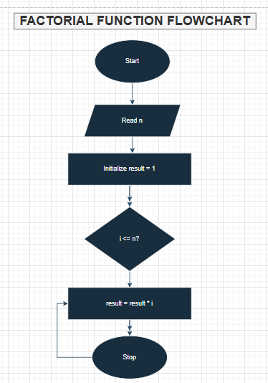
Fabonacci Workflow
1.Start
2.Input:Read Number N
3.Initialise:First Two Terms A = 0, B = 1
4.Loop:Generate Next Terms As A + B,Update Values
5.Repeat Until N Terms Are Generated
6.Display Sequence
7.End

Fabonacci Pseudocode
Begin
INPUT n
SET a = 0, b = 1
OUTPUT a, b
FOR i = 3 To n
next =a + b
OUTPUT next
a = b
b = next
END FOR
END
Fabonacci Python Code
def Fabonacci(N):
Sequence = []
a, b = 0, 1
For i In range (N):
Sequence. apppen(a)
a, b = b, a + b
return sequence

